**YESSY’S DJANGO PROJECT**GITHUB LINK: https://github.com/YessyLee/she-codes-django-news-project-YessyLee

**Notes:**   
My apologies Rebecca & Sophie, I took too long to style the pages and I am running out of time now, so it’s only halfway styled. I will keep working on the styling after the submission. I may need to book 1:1 session soon to properly understand the concept. I have found some of these codes through Googling and Youtube videos. Thanks

**Screenshots**

**Homepage 1 – logged in vs. not log in**

**Story page – logged in vs. not log in**  
Notes: Styling incomplete, need to work on the clickable links to make it obvious  
  
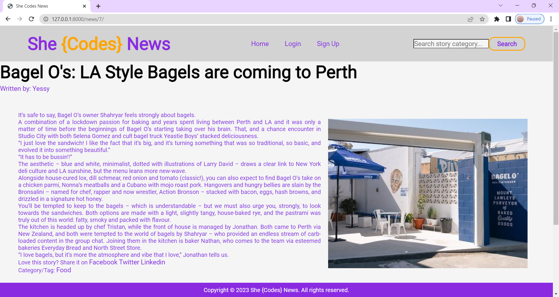

**User profile page – when logged in**  
Notes: Styling incomplete, sorry the page when not login in terrible, didn’t screenshot it as I need to work on the styling properly

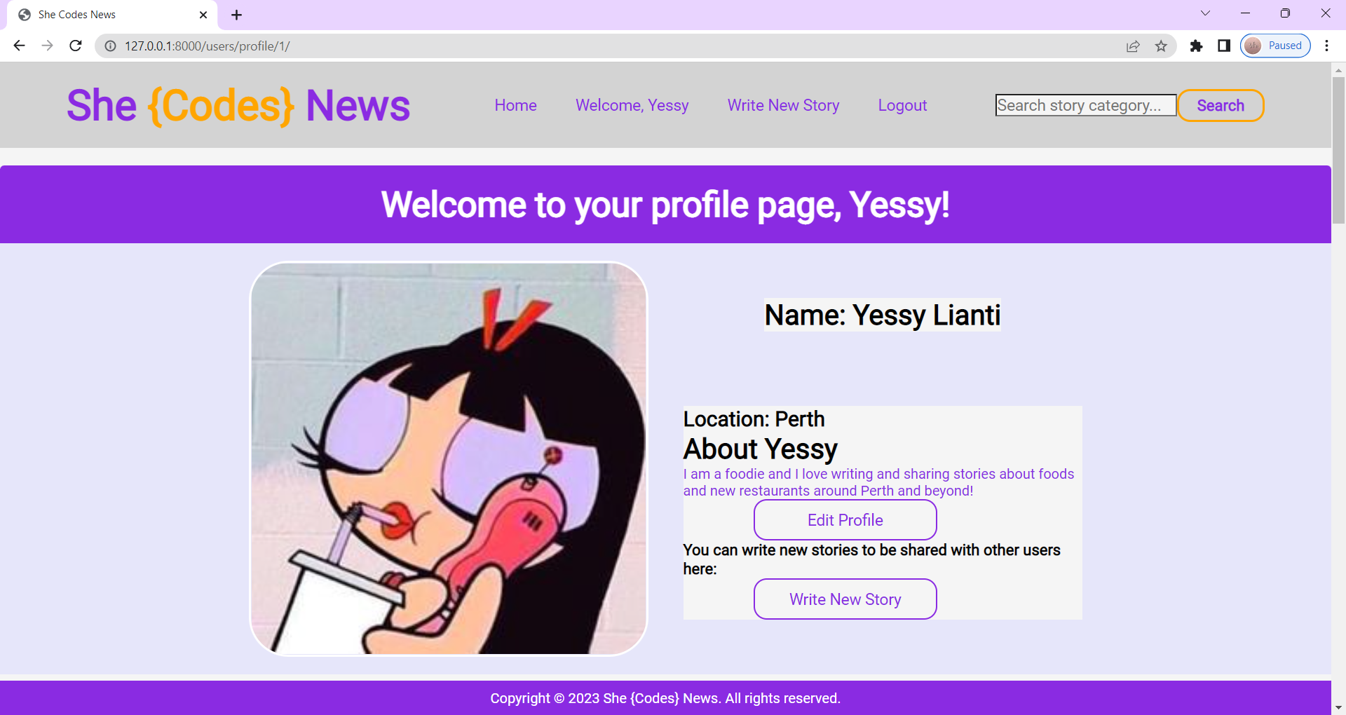

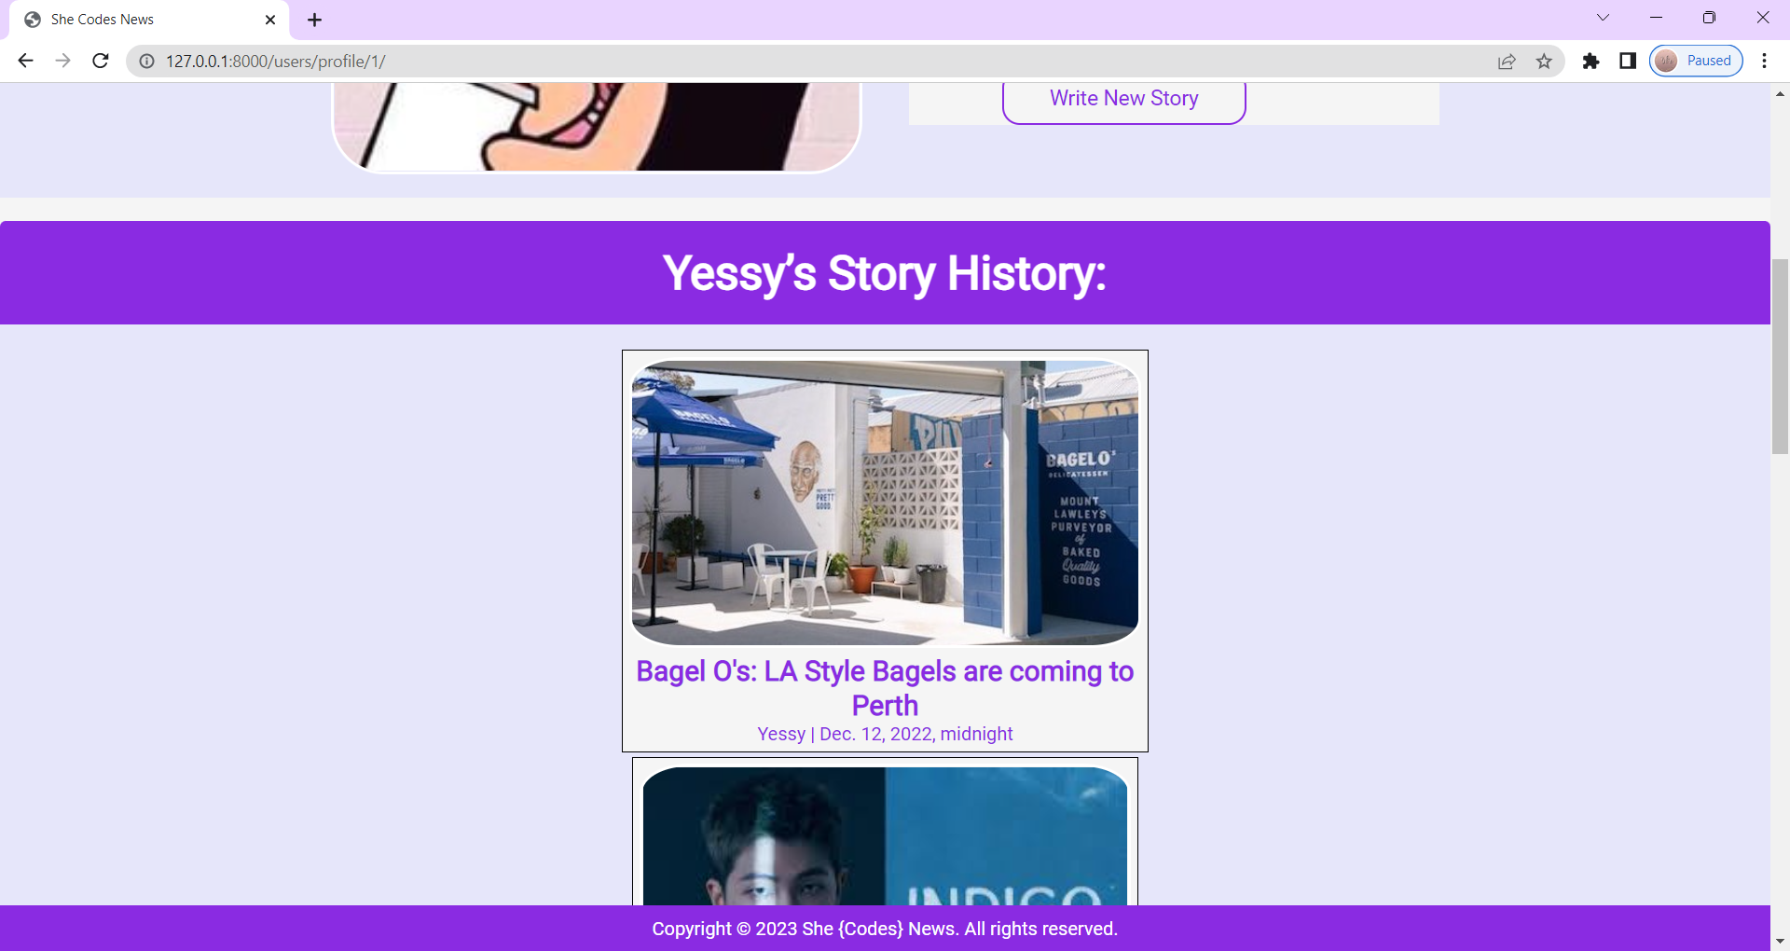

**Search Category (No styling yet)**

**FORMS**Notes: Some of the styling need some work

**VIEW AUTHORS**  
Notes: No styling yet

**DELETE POST/STORY WARNING**  
Notes: No styling yet

